Amruta Institute of Engineering and Management Science



REPORT
Monitoring the air quality through different gas sensors

Subject: Principles of Programming using C
Subject Code: BPOPS203
Course Coordinator: Prof. Shreyas Shivananjappa

Submitted by:
Shivarama R
Srujana Deshpande
Simon Leo Alexander
Yogeshwari R
Tanush G Balegar

Table of Contents
- Abstract
- Introduction
- Objectives
- Block diagram
- Proposed Methodology
- Hardware & Software requirements
- Component description
- Work done
- Result
- Conclusion
- Reference

Abstract:
In recent years, the importance of monitoring air quality has become increasingly evident due to its significant impact on public health and the environment. This project presents a comprehensive air quality monitoring model designed to measure and analyze various air pollutants in real-time. The system utilizes low-cost, high-accuracy sensors integrated with an ESP32 microcontroller to monitor pollutants such as carbon monoxide (CO), nitrogen dioxide (NO₂), particulate matter (PM₁₀ and PM₂.₅), and ozone (O₃).
Data collected by the sensors is transmitted wirelessly to a central server, where it is processed and analyzed to provide actionable insights. The model employs machine learning algorithms to predict air quality trends and identify potential sources of pollution. A user-friendly web interface and mobile application are developed to display real-time air quality data, alert users to hazardous conditions, and offer recommendations for mitigating exposure to pollutants.
This model offers a scalable and cost-effective solution for continuous air quality monitoring in urban and rural areas. By providing timely and accurate data, the system aims to empower individuals, communities, and policymakers to make informed decisions and implement strategies to improve air quality and public health outcomes.

Introduction:
Air is getting polluted because of release of toxic gases by industries, vehicle emissions
and increased concentration of harmful gases and particulate matter in the atmosphere. The level of pollution is increasing rapidly due to factors like industries, urbanization, increasing in population, vehicle use which can affect human health. Particulate matter is one of the most important parameter having the significant contribution to the increase in air pollution [2]. This creates a need for measurement and analysis of real-time air quality monitoring so that appropriate decisions can be taken in a timely period. This paper presents a real-time standalone air quality monitoring. Internet of Things is nowadays finding profound use in each and every sector, plays a key role in our air quality monitoring system too. The setup will show the air quality in PPM in webpage so that we can monitor it very easily. In this IoT project, you can monitor the pollution level from anywhere using your computer or mobile [1]. The setup will show the air quality in PPM in webpage so that we can monitor it very easily. In this IoT project, you can monitor the pollution level from anywhere using your computer or mobile. Air condition is much polluted. In recent years, car emissions, chemicals from factories, smoke and dust are everywhere. That is the reason why now air condition is much polluted. The effect of air pollution is very bad for our health, especially for place where the air in our body is taken for breathing. In our lungs may cause some diseases, such as asthma, cough, lung disorders [1].The air pollution cannot be detected by human feelings. The air pollution may contain a lot of dangerous substances, such as LPG gas, carbon monoxide, and methane [2]. Substances in the polluted air are very dangerous. For example, if the carbon monoxide is above 100ppm, it makes human feel dizzy, nauseous, and within minutes they could die. This research makes human find out which content of the air is polluted. With module Node MCU esp32, we can monitor the air pollution remotely, because there is a Wi-Fi in Node MCU esp32. This makes the air condition can be monitored every time
Keywords – Wireless Sensor Network (WSN), Air Quality Monitoring Systems (AQMS), Gas Sensors (CO).

Objectives:
The primary objectives of the air quality monitoring system are as follows:

- Measure and analyze air pollutants: Accurately monitor key air pollutants such as particulate matter (PM₂.₅ and PM₁₀), nitrogen dioxide (NO₂), carbon monoxide (CO), and ozone (O₃).
- Provide real-time data: Ensure continuous monitoring and provide real-time air quality data to users.
- Enable data-driven decisions: Support policymakers and the public in making informed decisions regarding air quality and health.

Block diagram:
AIR QUALITY
SENSOR (MQ-135 gas sensor)

POWER
SUPPLY
IOT (Node
MCU)
A
R
D
U
I
N
O

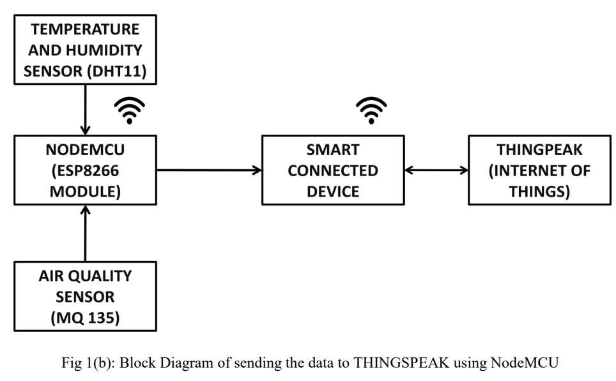

Proposed methodology:
We used Thingspeak IoT platform and we clearly defined the derivations that mentions the correct ppm on the screen with correct calibration. We have implemented it with less cost i.e., when we are pushing the data to the cloud, no need to see the output on LCD which adds more cost to the project [1]. When we are targeting IoT as a platform, our intension should be to present the idea on internet using the platforms like thinger.io or thingspeak or Cayenne website which are beautifully designed to present the output and even able to download the dataset. When doing an experiment air quality monitoring, no need to use LPG or methane detecting sensors as it is used for Home/office safety. We have used WiFi to push the data onto the cloud rather using GSM or GPRS module [2]. The problem in another paper that cited at [3] hasn’t calibrated the sensor and not even converted the sensor output value into PPM. As per the guidelines by UN Data, 0-50 PPM is SAFE value, 51-100 is moderate as shown in figure 1. Delhi is the most polluted city in the world recorded around 250PPM. As we are using two sensors, both of them have internal heat element, it draws more power(P= V*I), so though the both sensors are turned ON, its output voltage levels varies and shows unpredictable values due to insufficient power drive. We have used Arduino Uno Development kit that comes with ESP-32 microcontroller. In order to provide WiFi Support for it, we have used cost effective Air Quality Monitoring System ESP-32 WiFi module which helps us to connect to the ThingSpeak Platform. The connections between them is mentioned in the connections diagram.

Hardware requirements:
- ESP-32 microcontroller
- Temperature and Humidity sensor (DHT11)
- Air Quality sensor (MQ 135)
- IOT. (node MCU)

Software requirements:
- Arduino (Version 1.8.2)
- THINGSPEAK website

Component Description:
Temperature and humidity sensor (DHT11):-
DHT11 digital temperature and humidity sensor is a composite Sensor contains a calibrated digital signal output of the temperature and humidity. Application of a dedicated digital modules collection technology and the temperature and humidity sensing technology, to ensure that the product has high reliability and excellent long-term stability. The sensor includes a resistive sense of wet components and an NTC temperature measurement devices, and connected with a high-performance 8-bit microcontroller.
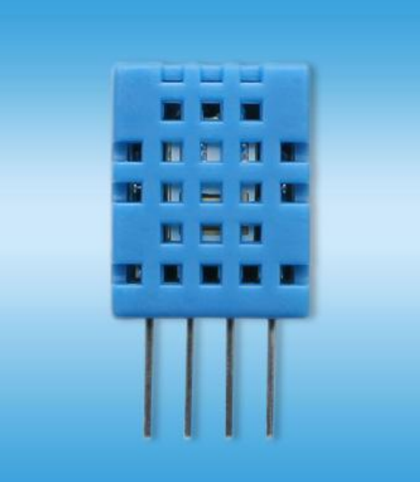
DHT11 Sensor
Pin Description:
• 1, the VDD power supply 3.5～5.5V DC
• 2 DATA serial data, a single bus
• 3, NC, empty pin
• 4, GND, used to connect the module to system ground

Air Quality Sensor (MQ135):-
Product Description: Air quality click is suitable for detecting ammonia (NH3), nitrogen oxides (NOx) benzene, smoke, CO2 and other harmful or poisonous gases that impact air quality. The MQ-135 sensor unit has a sensor layer made of tin dioxide (SnO2), an inorganic compound which has lower conductivity in clean air than when polluting gases are present. To calibrate Air quality, use the on-board potentiometer to adjust the load resistance on the sensor circuit.
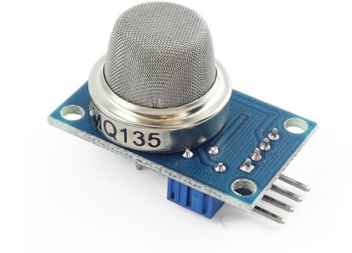
MQ-135 sensor
Pin Description:
- 1, the VDD power supply 5V DC
- 2,GND , used to connect the module to system ground
- 3, DIGITAL OUT, You can also use this sensor to get digital output from this pin, by setting a threshold value using the potentiometer
- 4, ANALOG OUT, This pin outputs 0-5V analog voltage based on the intensity of the gas.

Esp-32 microcontroller:
The ESP32 is a highly integrated microcontroller chip developed by Espressif Systems, renowned for its robust wireless communication capabilities. It features a dual-core Xtensa LX6 CPU that operates at up to 240 MHz, providing substantial processing power for complex applications. The ESP32 is equipped with integrated Wi-Fi and Bluetooth connectivity, supporting both Classic Bluetooth and Bluetooth Low Energy (BLE), making it ideal for a wide range of IoT applications such as smart home devices, wearable electronics, and industrial automation systems. Additionally, the chip is designed for low power consumption, offering various power-saving modes, including deep sleep, which makes it well-suited for battery-powered devices.
The ESP32 offers a rich set of peripheral interfaces, including numerous GPIO pins, ADC and DAC channels, PWM outputs, and communication protocols like I2C, SPI, UART, and I2S. These features allow it to interface seamlessly with sensors, actuators, and other hardware components. It also includes advanced security features such as hardware encryption, secure boot, and flash encryption to protect data and ensure secure communication. Developers can program the ESP32 using various development environments, including the Arduino IDE, MicroPython, and Espressif’s ESP-IDF, which provides flexibility in application development. Overall, the ESP32’s combination of performance, connectivity, and versatility makes it a popular choice for modern IoT solutions.
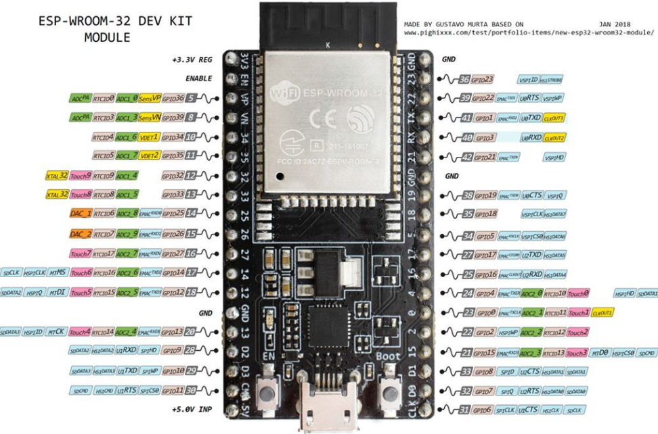
ESP-32 microcontroller

Flowchart for Displaying the Temperature, Humidity and Air Quality on Thingspeak:
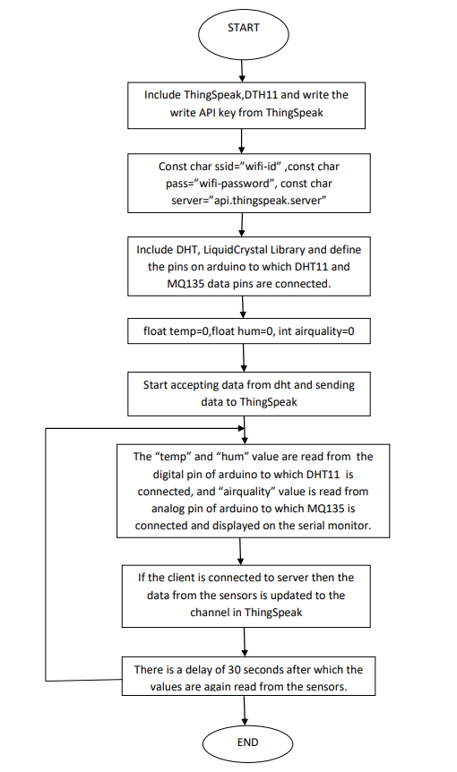

Work done:
Connections:
- The data pins of DHT11 are connected to Digital pin of ESP-32 and that of MQ135 is connected to Analog Pin.
- MQ135’s voltage and ground are connected to +5V and 0V and analog output pin is connected to analog Pin D34 of ESP-32.
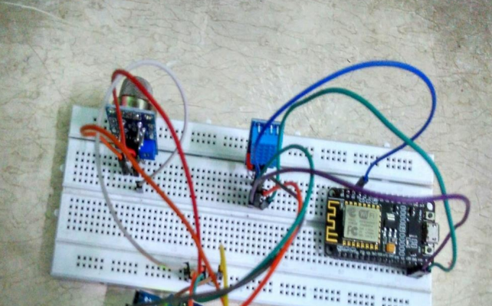
Connection of MQ-135 and DHT11 with ESP-32

Result:
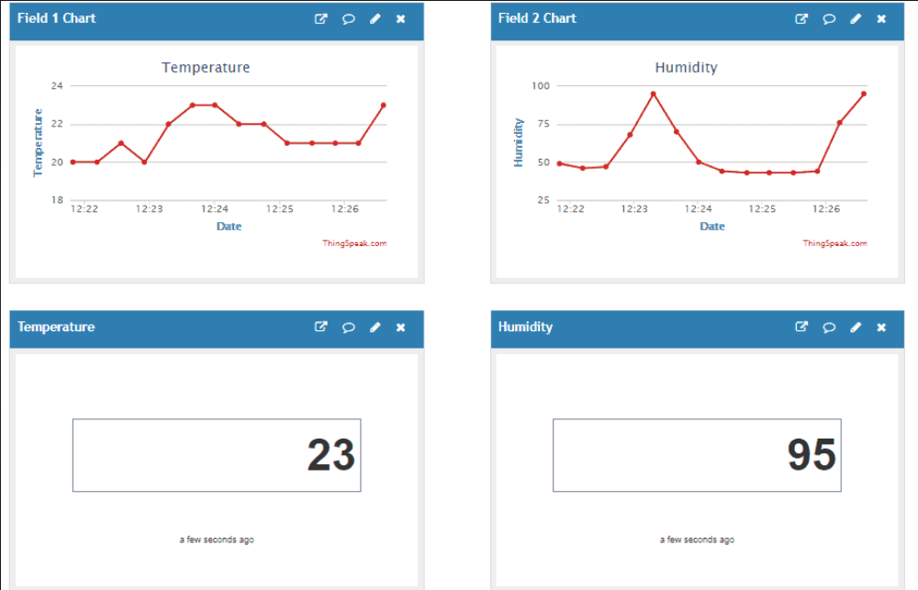
After connecting the WIFI successfully to the ESP-01, it gets established with Thingspeak account with the help of the API key of our account provided. Thingspeak needs 15 seconds of refresh interval to push to the data. Fig 7 shows the field charts of MQ135 and MQ7 sensor values which made to convert to PPM. Fig 8 showing the graphical analysis of the values collected with time on X axis and AirQuality PPM on Y axis.
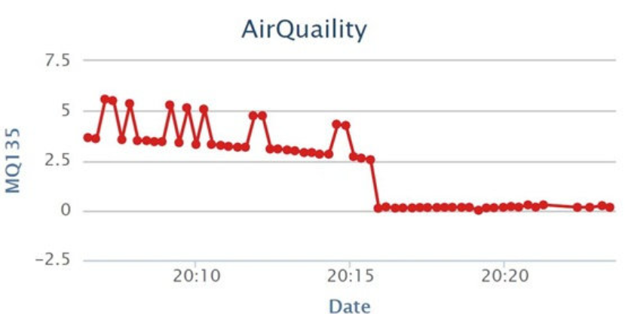

Conclusion:
Air quality monitoring systems are designed using different sensors for indoor and outdoor air quality monitoring in the previous works by using Bluetooth, GPS, GPRS wireless technologies. In a previous work WASP module is used which is costly. Instead of that different sensors can be used. The proposed system is developed for indoor air quality monitoring remotely. It is cost and energy efficient request and respond protocol is used along with combination of address and data centric protocols. Paper presents the summary of various techniques of air quality monitoring. These techniques are elaborately discussed in the paper. In the proposed system, one of the most preferred techniques is cloud based air quality monitoring system. Using the same cloud data, website is hosted and data is displayed on the website.

References:
- Poonam Paul, Ritik Gupta, Sanjana Tiwari, Ashutosh Sharma, “IoT based Air Pollution Monitoring System with Arduino”, IJART, May 2005.
- Zishan Khan, Abbas Ali, Moin Moghal, ”IoT based Air Pollution using NodeMCU and Thingspeak”, IRANS, pp. 11-16, March 2014.
- SaiKumar, M. Reji, P.C. KishoreRaja ”AirQuality Index in India”, IEEE conference Chennai, August 2014.
- Mohan Joshi, ”Research Paper on IoT based Air and Sound Pollution monitoring system”, IETS Journal, pp. 11-17, September 2015.
- ”Malaya Ranjan, Rai kumar, ”Understanding Parts per million in real time air quality index”, Journal of Mathematics and advanced sciences, pp. 23-29, September 2009
- D. Bandyopadhyay and J. Sen, “Internet of Things: Applications and Challenges in Technology and Standardization,” Wirel. Pers. Commun., vol. 58, no. 1, pp. 49–69, May 2011.
- L. Atzori, A. Iera, and G. Morabito, “The Internet of Things: A Survey,” Comput. Netw., vol. 54, no. 15, pp. 2787–2805, October 2010.
- H. Kopetz, Real-Time Systems: Design Principles for Distributed Embedded Applications. Boston, MA: Springer US, 2011, ch. Internet of Things, pp. 307 - 323.
- A. Gluhak, S. Krco, M. Nati, D. Pfisterer, N. Mitton, and T. Razafindralambo,
- “A Survey on Facilities for Experimental Internet of Things Research,” IEEE
Communications Magazine, vol. 49, no. 11, pp. 58–67, November 2011.

Thank You

